PART 1. INTRODUCTION: KITCHEN VOCABULARY
Brainstorming
How many words in English do you know which are related to the Kitchen environament??
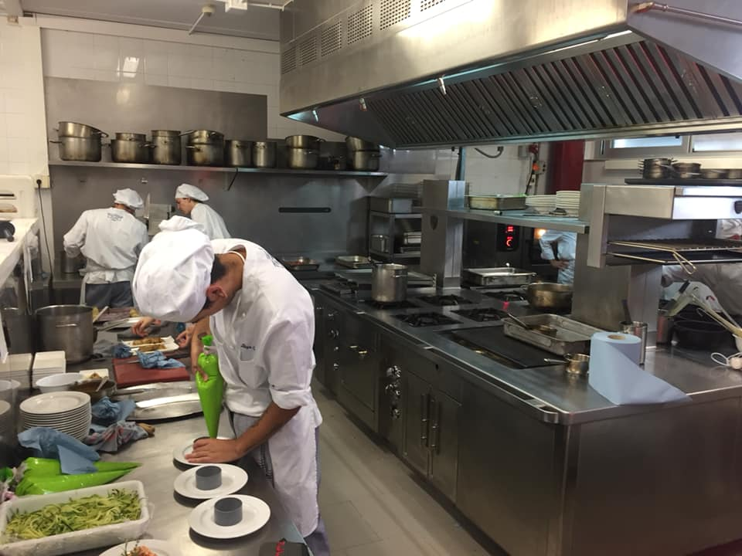

1. Match the definitions (A, B, C or D) with the correct image (1-3).

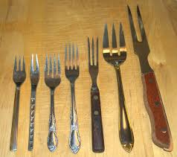
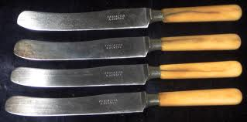
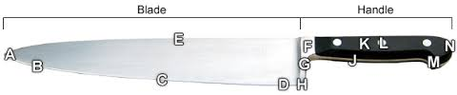

1. Blade & Handle
3. Carving Knife
2. Prong or Tine

A____
A sharp point, as of a fork.
B____
You take this by the hand.
C____
It is a large knife (between 20 cm and 38 cm) that is used to cut meat, including poultry, roasts, hams, and other large cooked meats.
D____
the flat cutting part of a knife.

2. Match the following words with the correct image.
stove tops, gas oven, gas grill, convection oven, ice cream machine, electrical cords, knives, portioning scales, robot coupe/grater, hand mixer, chinois, slicer, deep fat fryer, mandolin, meat grinder, juicer,

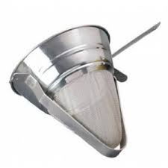  A______________ | 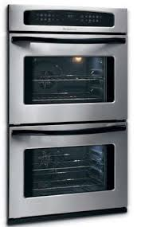B.________________ | 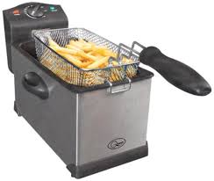  C._______________ | 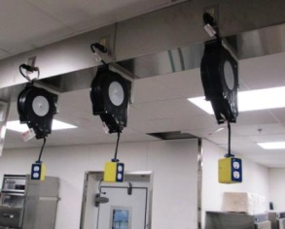  D._____________
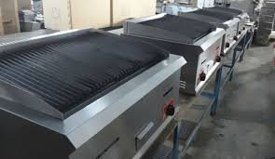  E._____________ | 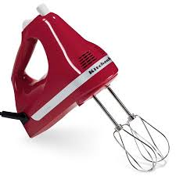  F._______________ |  | 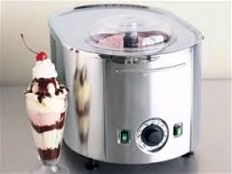  H._____________
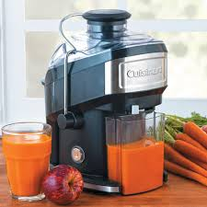  I.__________________ | 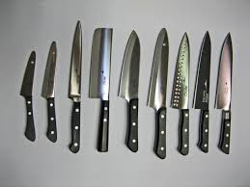  J.________________ | 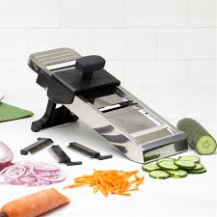  K.________________ | 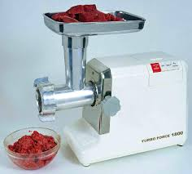  L._____________
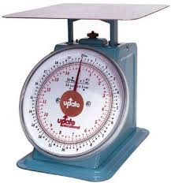  M._________________ | 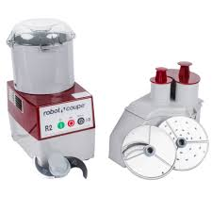  N._______________ | 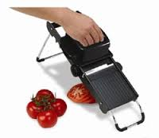  O.________________ | 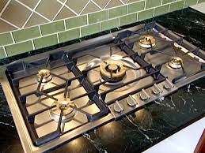  P._______________

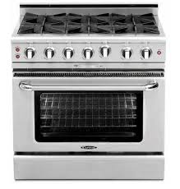

Q.________________

3. Translate the words in exercise 3 into catalan.


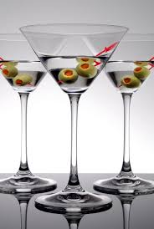


Champagne flute
Cocktail glass
Tumbler

4. Match the definitions (A, B, C or D) with the correct types of glass(1-4).
1. Tumbler 2. Cocktail glass 3. Champagne flute 4. Wine glass

A. ______________
It is a glass with an inverted cone bowl. They are often referred to as martini glasses, but they are different because the diameter of the bowl is smaller.
B. _______________
It is a type of glass that is used to drink wine. It is generally composed of three parts: the bowl, stem, and foot.
C. _______________
It is a stem glass with a tall, narrow bowl. The bowl of this glass may resemble either a narrow wine glass or a trumpet.
D. _______________
It is a glass with a thick foot used for serving an alcoholic beverage, such as whisky, with ice cubes (“on the rocks”). It is also normally used to serve certain cocktails. They usually have a thick base.

PART 2. RESTAURANT JOBS

1. Listen to the dialogue and and tick the jobs that are mentioned:
Pastry chef | Bartender | Kitchen porter | Host  (ess) | Chef de partie | Waiter | Sous chef | Wine steward | Commis chef | Head chef | Restaurant manager

1.1. Now match the mentioned jobs to their duties:
___________ bakes all the bread, rolls, and croissants.
___________ is responsible to the sous chef.
___________ prepares the vegetables, sharpens the knives.
___________ writes the menus.
___________ handles all the cold dishes, the sauces, and mayonnaise.
___________ prepares all the soups, hot starters, and side orders.

2. Listen again and complete the sentences.
1. He writes the menus and he’s responsible for the ___________ courses.
2. She ___________ all the soups.
3. The chefs de partie ___________ all the cold ___________.
4. He ___________ all the bread.
5. The kitchen porters have lots of ___________.
6. They prepare the vegetables, ___________ the knives, and ___________ the ovens.

3. Match the jobs in the box to their corresponding definitions.
bartender, restaurant manager, wine steward, waiter, host/ess

a. ___________ is responsible for serving and selecting wines.
b. ___________ prepares and serves drinks.
c. ___________ shows customers to their seats and gives menus .
d. ___________ takes orders and delivers food.
e. ___________ is the CEO/boss of the restaurant .

3. Match the following french words to their English synonyms:
Sommelier, maître, chef de cuisine, serveur
Restaurant manager | Waiter | Wine steward | Head chef

Write 4 other hospitality jobs that are the same in French than in English:
____________________________________________________________

4. Work with your partner to identify and classify the following sentences in the correct column.

1- "This week I’ll introduce a new main course.”  2- “What would you like to drink, sir?”  3- “How many onions do you want me to cut?”  4- “Benny, cut me 6 onions and 8 carrots.” | 5- "I recommend the Sauvignon Blanc, sir.”  6- “Guys, prepare yourselves, we have 100 dinner guests.”  7- “We have salad and pasta as a starter.”  8- “I’ll cut the peppers and leave them here.” | 9- "Where are the peppers Benny???.”  10- “This wine is fruity and sweet.”  11- “Red wine goes better with the steak tartar, sir.”  12- “Would you like some dessert madam?”

Head chef | Commis chef | Sommelier | Waiter | Assistant chef

5. Read the following text and put the jobs in the box in the correct column.

Pastry chef, Bartender, Kitchen porter, Host(ess), Chef de partie, Waiter, Sous chef Wine steward, Commis chef, Head chef, Restaurant manager

RESTAURANT STAFF POSITIONS
Back-Of-The-House Jobs (BOH)
Back-of-the-house positions pertain to the preparation of food, as well as the dishwashing staff. Small restaurants might only have a single chef or cook. Larger places might have an entire food preparation team, including a chef, sous chef, prep cook, line cook, and baker, plus a kitchen manager responsible for training, inventory, and other supervisory and administrative duties.
Front-Of-The-House Jobs (FOH)
Front-of-the-house positions are those that deal directly with the public. These titles may include host or hostess (or maître, in more refined restaurants), server (or waiter/waitress), busser (or busboy/busgirl, or back waiter), runner, sommelier and bartender.

Back-House | Front-House

……………………………………………………..

What preposition should be used after responsible?
Responsible is usually followed by the preposition for. When the adjective responsible is used to describe a person who has the job of managing something, it is followed by the preposition for.
Examples:
- The receptionist is responsible for [=has the job of managing] taking room reservations.
- The pastry chef bakes all the bread, rolls and croissants. He’s responsible for the hot desserts.
When responsible is used to mean "capable," no preposition is used, as in these examples:
- She is a very responsible assistant chef.
- Is he responsible enough to manage a kitchen?
Sometimes, responsible is used to describe someone who is working under the direction of a specific person in an organization. In this case, responsible is followed by the preposition to:
- The receptionist is responsible to the receptionist manager. (the reception manager is her boss)

6. Complete the sentences using responsible, responsible to or responsible for.
a. The cashiers are ____________ the reception manager.
b. The waiters are ____________ taking orders.
c. The duty manager is ____________ all the full time staff.
d. The porters are ____________ taking the guests’ luggage to their rooms.
e. The bar,man is ____________ the bar manager.
f. He is the most ____________ restaurant manager I’ve ever met.
g. I would hire him, he is a very ____________ chef.
h. The car park attendant is ____________ parking the cars.

7. PRESENTATION.
Think about your ideal restaurant. Think about the following things:
- Name:
- Type of restaurant:
- Where is it located?
- Capacity:
- Describe at least 5 different members of staff within your restaurant: name, age, responsibilities…
Once you finish, present your restaurant and its staff to the rest of the class.

