Accidental Discoveries and Inventions

Re-order the sentences below to write a report about the discoveries and inventions that happened by accident.
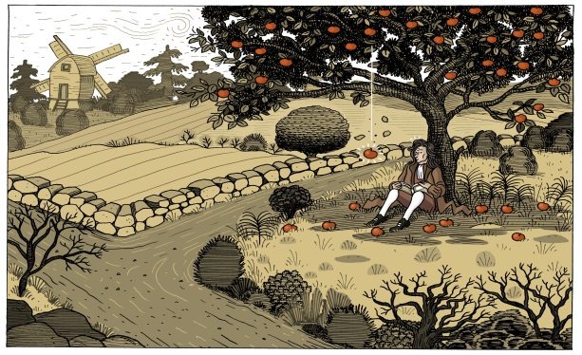
Issac Newton :
- sit / in / Newton / , / yard / when / his / he / apple / an / a tree / fall off.
- He / when / wonder / discover/ why was that/ he /gravity.

Christopher Columbus :
Christopher Columbus / when /to Asia / he /America / discover / sail .

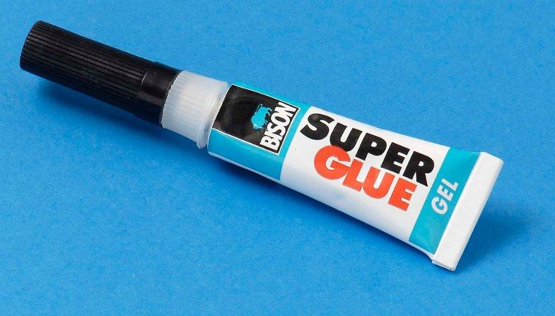

HarryCoover :
Harry Coover /attempt / to clear plastic/ for gun sights / glue / while/ he / invent /by accident.

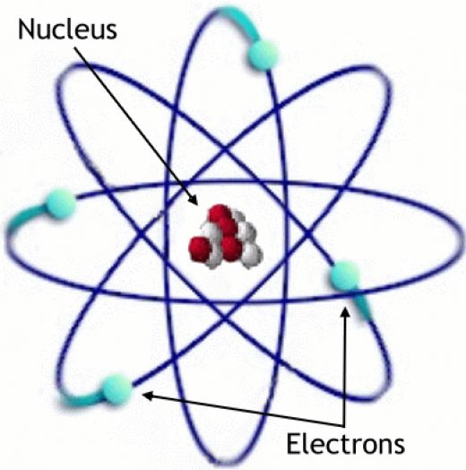

Joseph John Thomson :
Joseph J. Thomson/electric discharges/ laboratory/ his /while/ he/study/ discover/in / the electron.

