Find the money-related vocabulary in the word search. Words go across or down.

coins cash card fare  cash machine bank | P | C | O | I | V | T | B | A | N | G | F | F | T | T | C | piggy bank pay cheap  shopping price expensive
coins cash card fare  cash machine bank | X | R | B | C | O | I | N | S | X | R | G | B | O | C | A | piggy bank pay cheap  shopping price expensive
coins cash card fare  cash machine bank | B | C | I | C | D | D | Y | H | C | F | A | R | E | Z | S | piggy bank pay cheap  shopping price expensive
coins cash card fare  cash machine bank | N | W | E | C | E | F | G | O | Z | S | V | T | U | R | H | piggy bank pay cheap  shopping price expensive
coins cash card fare  cash machine bank | D | P | R | I | C | E | P | P | V | C | B | T | U | Y | M | piggy bank pay cheap  shopping price expensive
coins cash card fare  cash machine bank | R | R | E | D | B | O | Y | P | B | C | A | R | D | E | A | piggy bank pay cheap  shopping price expensive
coins cash card fare  cash machine bank | S | E | S | H | B | A | N | I | C | F | U | N | S | O | C | piggy bank pay cheap  shopping price expensive
coins cash card fare  cash machine bank | A | C | A | S | H | I | N | N | H | I | N | D | O | A | H | piggy bank pay cheap  shopping price expensive
coins cash card fare  cash machine bank | E | W | H | Y | A | R | E | G | E | S | E | A | T | B | I | piggy bank pay cheap  shopping price expensive
coins cash card fare  cash machine bank | T | A | P | I | G | G | Y | B | A | N | K | B | Y | V | N | piggy bank pay cheap  shopping price expensive
coins cash card fare  cash machine bank | Y | T | A | S | T | O | B | E | P | N | O | T | E | R | E | piggy bank pay cheap  shopping price expensive
coins cash card fare  cash machine bank | J | E | Y | D | B | A | N | K | U | O | O | U | R | U | F | piggy bank pay cheap  shopping price expensive
coins cash card fare  cash machine bank | N | A | V | G | Y | U | I | M | C | C | L | L | Y | G | I | piggy bank pay cheap  shopping price expensive
coins cash card fare  cash machine bank | I | X | T | E | X | P | E | N | S | I | V | E | Z | P | V | piggy bank pay cheap  shopping price expensive
coins cash card fare  cash machine bank | O | Q | Q | E | Z | V | N | I | O | P | J | M | E | E | O | piggy bank pay cheap  shopping price expensive

- Match the money words from the word search to the pictures.

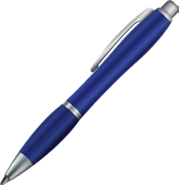
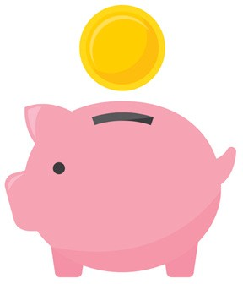
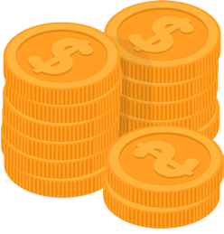
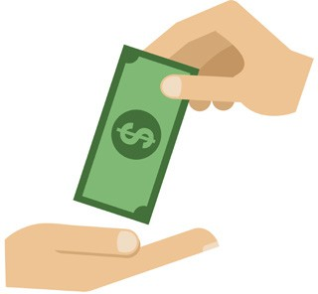
$1000

1. ....................... 2. ....................... 3. ....................... 4. .......................
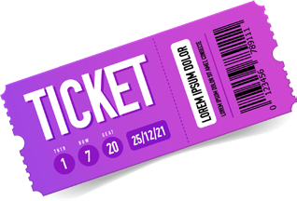
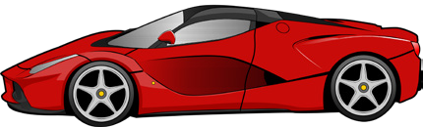


$100

5. ....................... 6. ....................... 7. ....................... 8. .......................
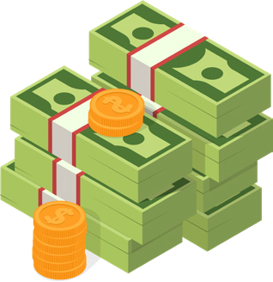
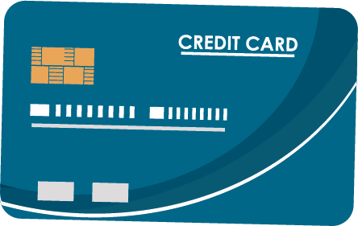
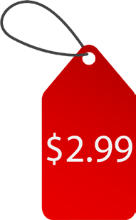
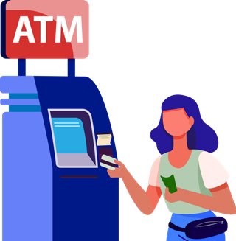
9. ....................... 10. ....................... 11. ....................... 12. .......................

Unscramble the words to form verbs that are used to talk about money.

1. cehgan | .................... | 5. akme | ....................
2. stoc | .................... | 6. fera | ....................
3. dspne | .................... | 7. eexvpiesn | ....................
4. seav | .................... | 8. cphae | ....................
- Complete the sentences with the money-related verbs. You may need to change the form of the verb. Use each verb once.

  - I am going to up my money, so I can buy a house.

  - I don't have much money, so I can only buy a car.

  - She went shopping every day last week and all her money!

  - I hope to be rich in the future, so I can buy an house.

  - After I paid my bill, the waiter brought me my ....................
  - Before you can get on the bus, you have to pay the ....................
  - They didn't pay me much, but hopefully I'll more money in my next job.

  - That dress is beautiful. How much did it ?

Complete the story with the money words from the box. Use each word once.

price | make | fare | cheap | bank card | expensive
cash | change | save | bank | shopping | cost

Jack was in the (1) because he needed money. He walked to the machine and

took out (2) .................... with his (3) He then walked to the station. Jack
paid his (4) .................... and got on the train to the city. His plan was to go (5) ....................
and buy a gift for his wife's birthday. He doesn't (6) a lot of money, so it took a

long time to (7) for the gift. While walking in the city, he saw a beautiful coat

in a shop window. He thought it would look great on his wife, but he wasn't sure how much it

(8) .................... It was made in Italy, so he thought it would not be (9) Jack
walked into the shop to ask the owner the (10) of the coat. When he was told,

he was very surprised to know that it wasn't too (11) He was very happy to

walk out of the shop with the coat and some (12) in his pocket.

