
1. Personality is an important piece of information when we talk about jobs. Look at the slides your teacher is going to show and classify the following expressions in the correct column:
A- "All the 6 chefs in the restaurant answer to him”.  B- "He has a 12 hour shift from Tuesday to Sunday.”  C- "I wouldn’t mind eating insect if I were in Vietnam.”  D- "Let’s discuss how to modify the menu for next month.”  E- "There are three shelves in the fridge, one for fruit, one for meat and the other for vegetables.”  F- "I’m really excited about my new post as Commis Chef!!!!”  G- "Pete just punched him in the face, incredible!” | H- "If we want to finish we will have to work 15 hours in a row."  I- "We will cook the starters first, then the main dishes, and only then we will prepare the desserts."  J- “What do you think if I introduce a new tapa to the menu?”  K- "I can’t wait to start my new job at this restaurant!!!”  L- “If we agreed to make a meal for 40 people, we will have to do it, so let’s start!”.  M- "George stayed calm during all the robbery.” | N- "Sarah doesn’t want to move to a bigger city."  O- “We said the meal would be ready at 2pm, so let’s hurry!”  P- "If you have any problem, don’t be afraid to come and explain it to me.”  Q- "Yeah sure, let’s try that new restaurant."  R-"I’m all ears to new ideas”.  S- "I do really well under pressure."  T- “I’m an angry driver.”

Open-minded | Leadership | Hot-headed | Cool-headed | Committed

Enthusiastic | Organised | Hard-working | Communicative

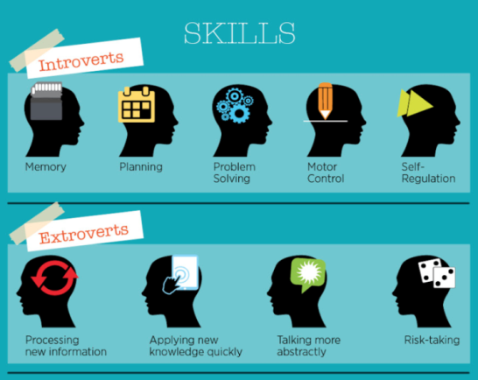


2. Watch the following scenes from The Simpsons associate each column to a character.

Learning
A | B
Intelligent  Clever  Smart | Unintelligent  Stupid  Silly

Ralph Wiggum:
__________


Lisa Simpson:
__________


Martin Prince:
__________
Working
C | D
Hard-working  Diligent  Ambitious | Lazy  Sluggish  Unambitious


Bart Simpson:
__________

3. Create a digital mind map with adjectives to describe a chef. Use www.popplet.com. (use at least 8 adjectives)
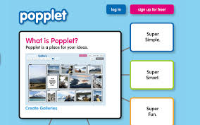

Once you finish, send the URL of your Popplet to the task in Suro.

4. Go to the following link (https://www.caterer.com/careers-advice/job-profiles) and read the following profiles:
- Head chef
- Sous chef
- Kitchen assistant
Now fill in the table.
 | SALARY | TASKS/DUTIES | SKILLS | QUALIFICATIONS
HEAD CHEF
SOUS CHEF
KITCHEN ASSISTANT

5. Go to the job-search websites below and find a hospitality job you’d be ready to accept.
https://findajob.dwp.gov.uk/
https://www.indeed.co.uk/

Explain the following aspects to the rest of the class:
- What is the position
- Type of business
- Location
- Duties & Responsibilities
- Personal qualities required
- Salary, schedule, etc.

Use the table below:
 | position | business | location | duties | qualities | salary
JOB:
________

