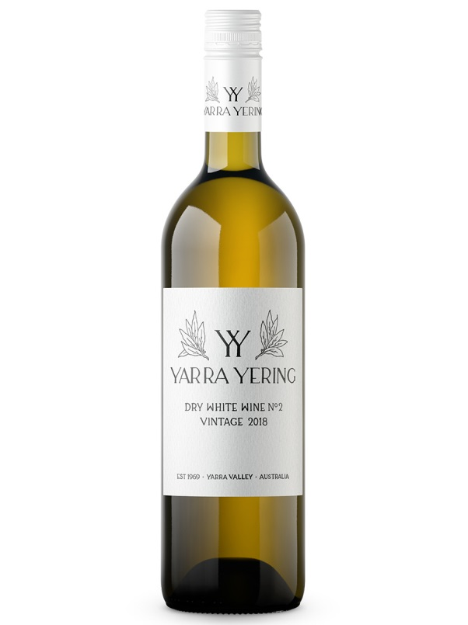
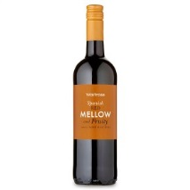
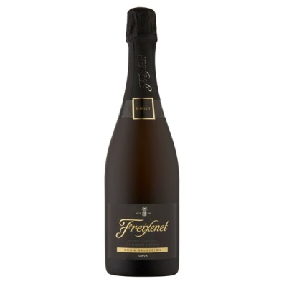
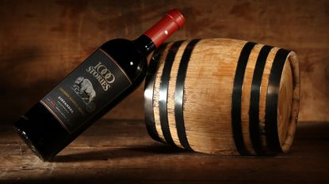
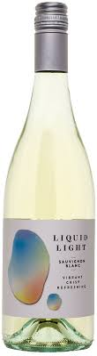

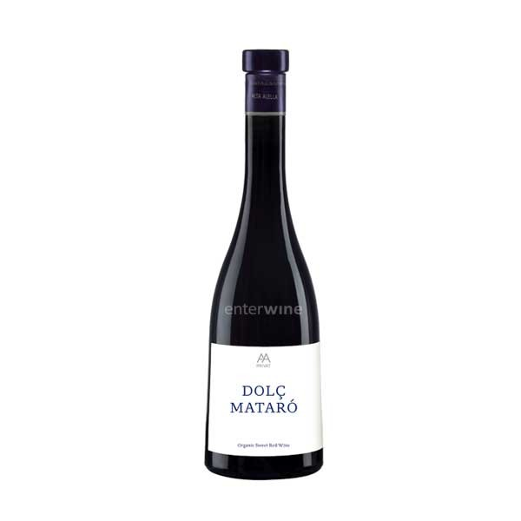
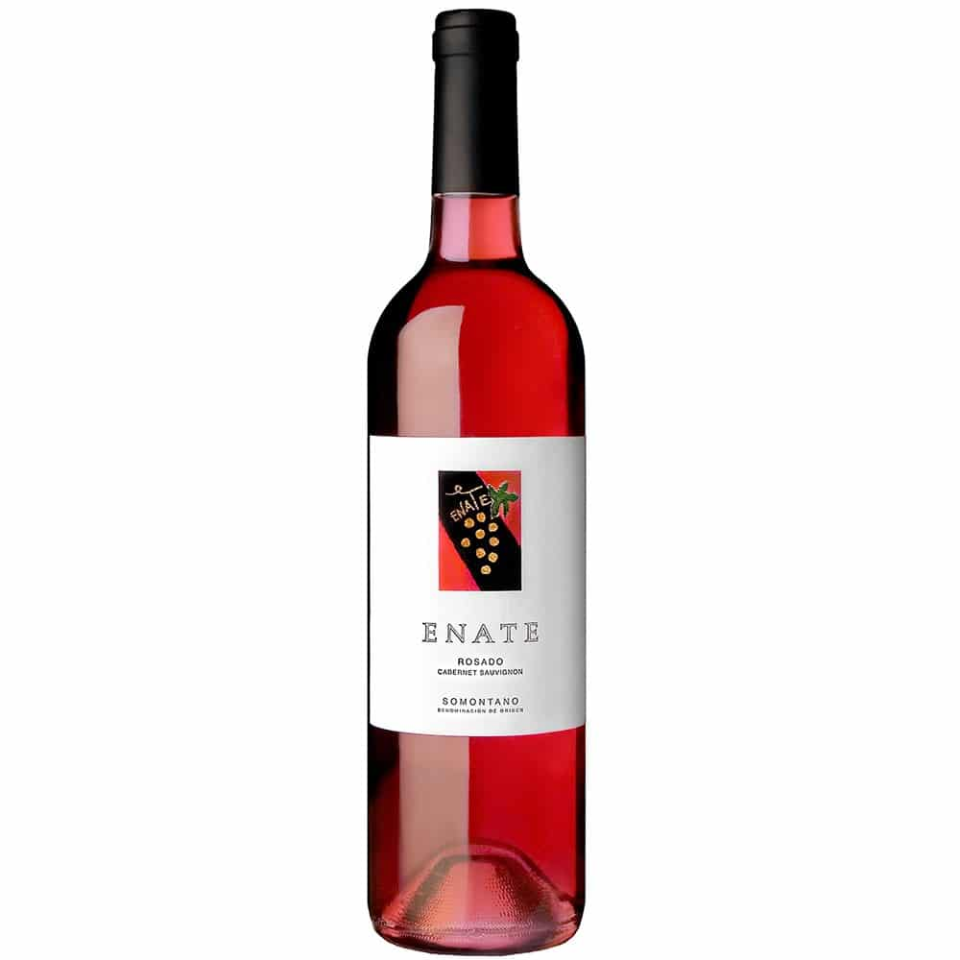

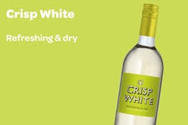

1. Match the following words to the images. What do they mean?
Crisp, sweet, rosé, light, mellow, oak-aged, dry, sparkling

2. Match the words in ex.1 to their definitions.
__________ food and drink contains a lot of sugar.
A __________ sound or flavour is pleasant, smooth, and rich.
__________ drinks are slightly fizzy.
__________ sherry or wine does not have a sweet taste.
___________ wine is wine that has been kept in oak barrels for its aging process.
Something that is __________ is not very great in amount, degree, or intensity.
__________ wine is refreshing and with high acidity.
__________ is wine which is pink in colour.

3. The words in the table are often used to describe wines. Match the words from ex.2 to those in the table with a similar meaning:

Pink | Smooth | Not heavy | Acid | Sugary | Fizzy | Non-sweet

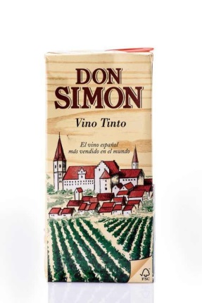
4. Work in pairs. How do you think these wines are? Talk to your partner.
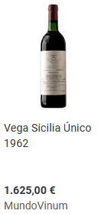
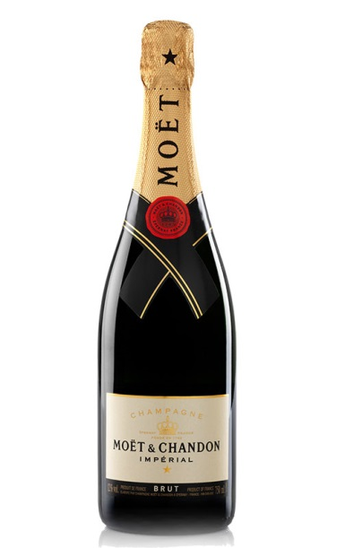

5. Work in pairs. Think about your favorite wine and write a short description.
________________________________________________________________________________________________________________________________________________________________________________________________________________________________________________________________________________________________________________________________________________________
d

Present it to the rest of the class.
6. Listen to the conversation in page 24 again and complete the sentences.
The woman orders a glass of…
The man orders a glass of…
The couple order a bottle of ____________ wine from ___________ and a bottle of ____________.
………………………………………..
6.1. Now put the following expressions in the correct column:
a. a bottle of sparkling water, please.
b. okay, so that’s a glass of Sauvignon Blanc, and a glass of…
c. the Sauvignon Blanc isn’t as dry as the Pinot Grigio.
d. Okay then, let’s have the French!
e. I’ll have a glass of Sauvignon Blanc then.
f. we’d like a bottle of red to go with our main course.
g. Would you like some mineral water?
h. Which is lighter, the French or the Chilean Merlot?
i. they’re both full-bodied wines.
j. would you like to order some wine with your meal?
k. you’d prefer something sweeter, don’t you?
l. Which is drier, the Riesling or the Sauvignon Blanc?
m. the Sauvignon Blanc is drier than the Riesling
n. I recommend the French. It’s more expensive than the Chilean but it’s smoother.
o. thank you madam.

WAITRESS | CUSTOMER

6.2. Go through the meaning of the expressions with the teacher.
6.3. Now put the sentences from ex.6 in the correct category:
WAITRESS | CUSTOMER
- The waitress offering:  - The waitress giving information:  - The waitress recommending:  - The waitress confirming the order:  - Thanking: | - Demanding information from the waitress:  - Ordering:  - Deciding on choice offered:  - Thanking:

7. Work in pairs. The teacher will give you some cards. Match some of the words listened with their definitions.
RIESLING
Type of white wine of German origin
e.g.

8. Read sentences h, k, l, n from ex. 6 and write down the adjectives used to compare wines. Can you make their superlatives?

8.1. Now listen to the explanation by your teacher and complete the exercises shown on the board (pdf COMPARATIVES & SUPERLATIVES).

9. ROLE PLAY. Work in groups of three. Prepare a conversation in which 2 customers order to the waiter:
- 2 glasses of wine
- 1 bottle of (different) wine
- 1 bottle of water
The customers must:
- Demand information of the wines
And the waiter must:
- Offer, give information and recommend.

You have the wine list below.

RED WINES:
- Ramon Bilbao ………………….… 15 euros (fruity, crisp, full-bodied, oak-aged)
- Luís Cañas ……………………….… 17 euros (dry, mellow, full-bodied, oak-aged)
- Muga ………………………………… 23 euros (mellow, light, oak-aged)
WHITE WINES:
- Protos ……………………………….. 13 euros (dry, light)
- Blanc Pescador ………………….. 9 euros (fruity with a touch of citrus, light)
ROSÉ WINE:
- Marqués de Cáceres ………….. 12 euros (fruity, mellow, sparkling)

TRANSCRIPT:
Waitress: would you like to order some wine with your meal?
Customer 1: yes please. Which is drier, the Riesling or the Sauvignon Blanc?
Waitress: the Sauvignon Blanc is drier than the Riesling but it isn’t as dry as the Pinot Grigio.
Customer 1: righ, uhm… I’ll have a glass of Sauvignon Blanc then. Nancy you’d prefer something sweeter, don’t you?
Customer 2: yes, a glass of Chardonnay, please.
Customer 1: then, we’d like a bottle of red to go with our main course. Which is lighter, the French or the Chilean Merlot?
Waitress: well, they’re both full-bodied wines. I recommend the French. It’s more expensive than the Chilean but it’s smoother.
Customer 2: Okay then, let’s have the French!
Waitress: thank you madam. Would you like some mineral water?
Customer 2: yes, a bottle of sparkling water, please.
Waitress: okay, so that’s a glass of Sauvignon Blanc, and a glass of…

