1. Complete the list of materials using a, e, i, o and u.
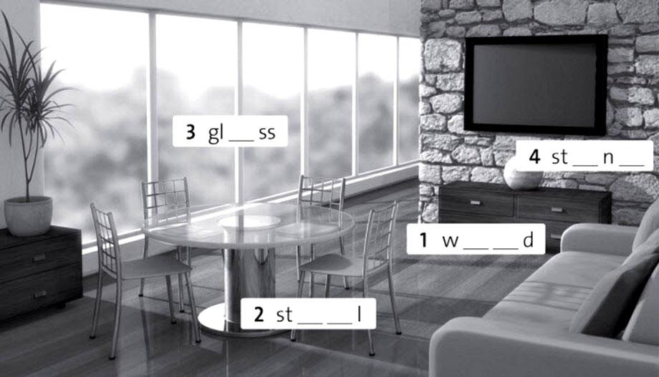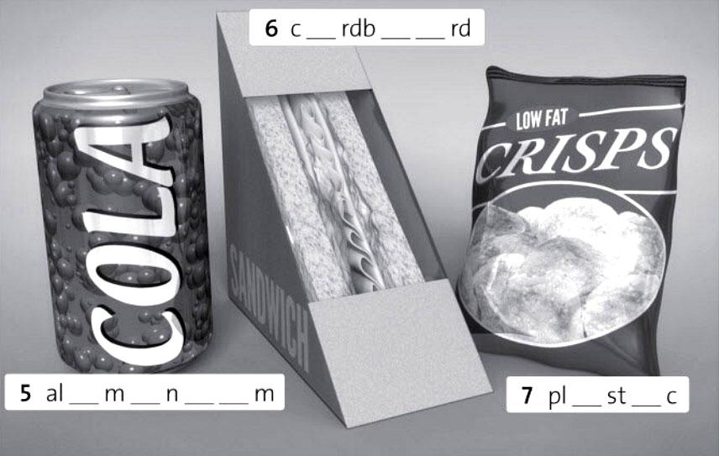

2. Complete the sentences with the correct materials.

rubber concrete iron paper leather ceramic gold
1 Shoes are often made of l…………………………
2 Expensive rings are often made of g…………………………
3 Car tyres are made of r…………………………
4 Cups and plates are often c………………………… but sometimes they are made of c…………………………
5 Books are made of p…………………………
6 Pavements are often made of c…………………………
7 Gates and fences are sometimes made of i…………………………

3. Answer the questions with the material words from exercises 1 & 2.
1 Which of the materials come from trees? paper …………………………
2 Which of the materials are metals? ………….. …………………………
3 Which material is made from part of an animal? ….…………………
4 Which very hard material do we find in the ground? …………………
5 Which man-made materials do we make from oil? ………………………
6 Which materials do we make from other materials which we find in the ground?
………………………… ………………………… ….…………………………

Order the words to write the names of the materials in the pictures and match them.
DOOW APPRE CNOOTT AABCDDORR AEEHLRT CHLOT EILRSV BBERRU CCEENORT AELMT LOOW
ACILPST ACLY DGLO AGLSS ENOST
1 2 3
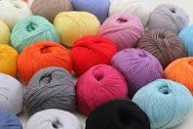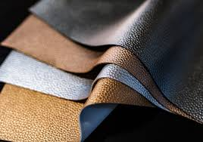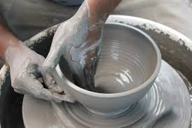
4 5 6
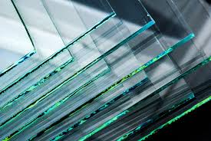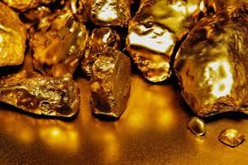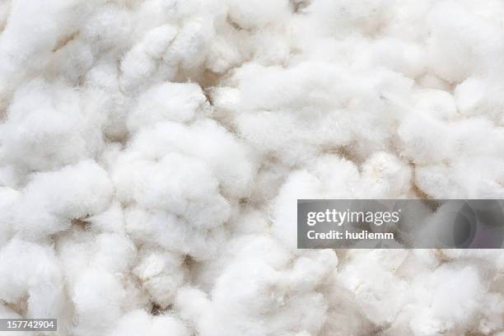
7 8 9
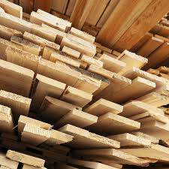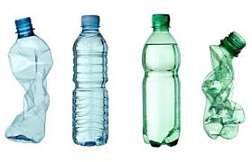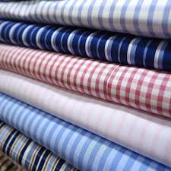
10 11 12
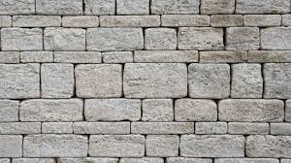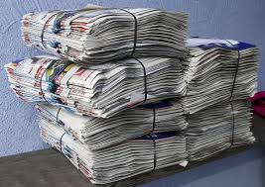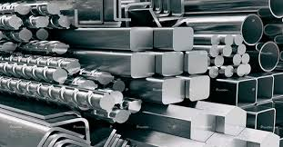
13 14 15 16
